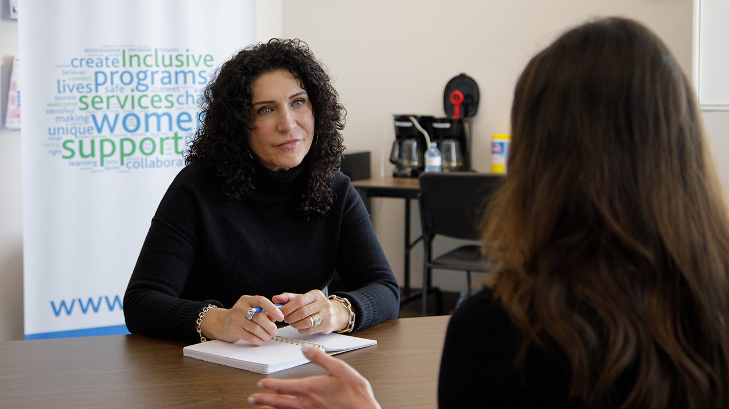  
**“THE SUPPORT GIVES US A SECOND CHANCE AT LIFE”**

**UNITED WAY CREATES SUPPORTIVE SPACES WHERE SURVIVORS OF ABUSE CAN HEAL, RECLAIM THEIR STRENGTH AND BUILD THE LIFE THEY DESERVE. ANY WAY WE CAN.**

As a teacher, Piera found daily moments of joy in the classroom. But at home, behind closed doors, life was different.

Piera was in an emotionally abusive relationship that was slowly eroding her sense of self. She carried that weight alone, beneath the familiar pressure to appear poised and calm. “I wanted everything to run smoothly because I didn't want anybody else to be impacted,” she shares. “I think as women, we take it all on. There was a lot of shame.”

Like so many survivors, Piera began second-guessing herself. Was she overreacting? Was it her fault? The uncertainty left her feeling trapped. “My self-esteem was very low,” she says. “I felt isolated.”

Then, her body started sending signals she couldn’t ignore. The relentless stress and self-sacrifice caused Piera to have panic attacks. That’s when she knew she needed help.

She turned to group therapy, which gave her a name for what she’d been living through. It was a form of gender-based violence — a growing crisis playing out across the GTA. In Ontario, 30 municipalities, including Toronto and Peel Region, have declared intimate partner violence an epidemic.

United Way Greater Toronto hears that alarm. It’s what gets us up every day, determined to support women and build safer, healthier communities. It’s why we’re [advocating for the provincial government to declare intimate partner violence an epidemic and step up support for survivors](https://www.unitedwaygt.org/public-policy/ontario-united-ways-open-letter-call-on-government-of-ontario-to-declare-intimate-partner-violence-an-epidemic/). And while we push for systemic change, we continue digging into the work, funding 50+ programs that help 48,000 survivors connect with a system of wraparound supports to live free from violence.

Through therapy, Piera learned about one of those programs — Making Changes at the [Women’s Centre of York Region (WCYR)](https://www.wcyr.ca/). Focused on helping women heal from trauma and enhance their mental well-being, the United Way-supported program offered what she needed most: the belief that a better life was possible.

**A journey to empowerment**

At first, Piera was nervous about joining the program. But something about it resonated with her. “I reached out because I felt that this was a place designed for women who needed a space, which I definitely did.”

Inside the centre, Piera found a community. Women who understood. Who listened. Who reminded her she wasn’t alone.

Encouraged by this empathy and support, she rebuilt her confidence. She learned to set boundaries, trust herself and form healthier relationships — with others, but more importantly, with herself.

“That was just the beginning of my journey,” explains Piera. “I had a strong desire to grow, to learn, to have a better life.”

She returned to the program twice more, gaining new insights with each session and witnessing others transform as well. As a teacher, Piera loved the moment when a student’s eyes would light up with understanding. Now, she saw that same spark in women like her. She volunteered to lead the program, determined to help others find the hope and healing she had discovered.

And she didn’t stop there. Piera went back to school and is now a registered psychotherapist. “I know how powerful it is to have someone truly listen and guide you without judgment,” she explains. “I wanted to offer that same support.”

**When women rise, communities thrive**

As Executive Director at WCYR, Nivedita has seen what can happen when survivors are met with understanding and community. They break through shame and self-doubt — and create change. “We've had women use our programs to navigate difficult divorces while protecting their children,” she says. “Others have re-entered the workforce after feeling stuck in a rut. We’ve seen a reduction in anxiety and depression.”

These are the kinds of outcomes United Way strives for. [Through research, advocacy and 110+ programs designed for women and women-identifying people](https://www.unitedwaygt.org/our-work/women/), we’re building a GTA where every woman has the chance at a healthy, stable life. That means opening pathways to meaningful work with fair wages. It means fighting for affordable housing, so women and families have a safe place to call home. And it means strengthening health and food supports, so no woman has to choose between rent and groceries.

And we’re fiercely dedicated to connecting survivors of gender-based violence with the resources to heal and move forward with dignity.

“The continuity and support United Way provides is really important,” says Nivedita. “Because if we suddenly had to stop the program, women who may have opened something raw wouldn’t have the support to close that wound and move forward.”

Piera understands this better than anyone. Her healing journey continues, but now she moves through life with self-compassion. She teaches her daughters to embrace their worth. She’s built a career helping others unlock their inner resilience. And when she meets survivors at WCYR, she reminds them of the strength they already carry.

Because she knows reaching out for help isn’t a weakness — it's one of the strongest things a person can do.

“You may not always see the direct impact of your generosity, but it changes lives,” says Piera. “I literally see these women talking about how they feel different. They are women like me. They walk in feeling really broken and walk out feeling hopeful, stronger and more capable. The support gives us a second chance at life.”

Women face complex challenges that can impact their well-being and opportunities. That’s why United Way works tirelessly to protect the spaces where women can create a path forward. And we’re not stopping there. We’re finding new ways to build a stronger, more equitable GTA for every woman who lives here. **Any way we can.**

For Piera, that meant reclaiming who she is. And building a life where she helps others do the same.