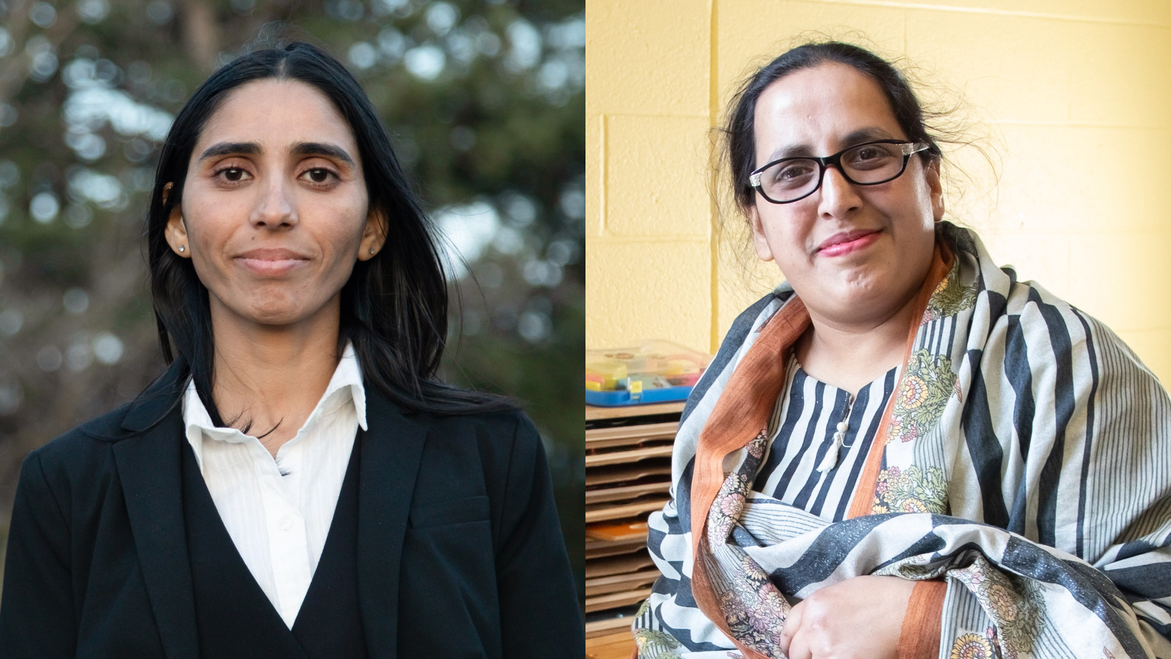

**How two sisters navigated their settlement journey**

**With hard work and a helping hand from a United Way-funded agency, Muffad and Shenawar built new lives in Canada**

When sisters Muffad and Shenawar came to Toronto from Pakistan in 2015 — with their siblings and mother — they were thrilled to reunite with their father, who immigrated first. But there was so much to navigate as newcomers: schooling, jobs, housing, social connections and endless paperwork — all in a new language.

“I felt very good about coming to Canada, but for the first two months, life was really hard for me,” says Shenawar, who was then 25. Communication was the biggest hurdle, explains Muffad, then 22. “My brother, he was the only one who could speak English. We understand a little, but we don't speak because we feel shy.”

Luckily, being here in Canada already, their father knew where the family could go for support — Rexdale Women’s Centre.

Rexdale Women’s Centre is one of 300+ United Way-funded agencies in Toronto, York and Peel Region. This network offers 49 settlement programs, used by more than 25,800 new Canadians a year. Immigrants play a crucial role in the economic, social and civic vitality of the GTA. But newcomers are at higher risk of experiencing poverty and face barriers like language fluency, racism, discrimination in the job and housing markets and limited social networks. Access to United Way-funded services can make all the difference.

“Right away we did some English workshops at Rexdale,” says Muffad. “I learned how to introduce myself, say when I came to Canada and how I liked it so far. They said, ‘good job!’ and I started building my confidence.”

The sisters returned each week for the Conversation Circle, where they met other newcomers. “I started feeling good in that time, and I made some life goals and then life started to get easier for me,” says Shenawar.

Once Muffad had felt more confident with her English, she looked to gain education here in Canada. “I went to adult high school and got credits. When I got that certificate, we were so proud,” she says. Her next goal: college. Her settlement worker at Rexdale Women’s Centre helped her fill out application forms and secure provincial bursaries and support from her school’s Financial Aid office. The agency also provided support for books and transit costs to ease the financial burden.

Meanwhile, Shenawar got married and started a family with her husband, Nadeem. Their children are now aged two and three. “They’re very young right now but like all parents I hope they have a bright future here,” Shenawar says.

At Rexdale Women’s Centre, her kids play in the family resource room while the grown-ups go to Conversation Circle or participate in other programs and access supports.

“Whenever we have any problem, I go to Rexdale. They tell me what options are available to me, so I know how to proceed in the future,” says Shenawar. “I got to know staff there from my culture, who speak the same language as me, so I felt comfortable.”

In college, Muffad began looking toward the future and career possibilities. With no Canadian work experience, she began volunteering at Rexdale Women’s Centre during workshops, loading the snack trolley for break time, then helping with clean-up.

 “That helped me get my first part-time job at McDonalds,” she says.

Muffad also attended a job fair at the agency, for which she built a resume and did interviews with recruiters.

“It was practice for me,” she says. “I was very confident after graduation that I could apply for a good job.”

Ultimately, she was hired as a bank teller — a stable job with a secure income. “The most enjoyable part for me is I help people,” says Muffad, adding that many regular customers wait in line to be served specifically by her.

When the sisters were applying to become citizens, the agency was there for them too. They met weekly with volunteers to prepare for the citizenship test. Muffad passed in 2023. Shenawar passed the following year. “Initially it was hard for me, but at Rexdale they highlighted the most important parts of the book and provided guidance, and then it was not so hard,” she says. “And now I am a Canadian!”

The road is never without bumps and barriers for newcomers. It takes work, patience, new skills and knowledge to build a life in a new place. Having culturally sensitive guidance can be a gamechanger.

“We were in the darkness when we came here,” says Muffad. “When you’re in the darkness, you welcome light. We got a light thanks to Rexdale Women’s Centre and United Way.”