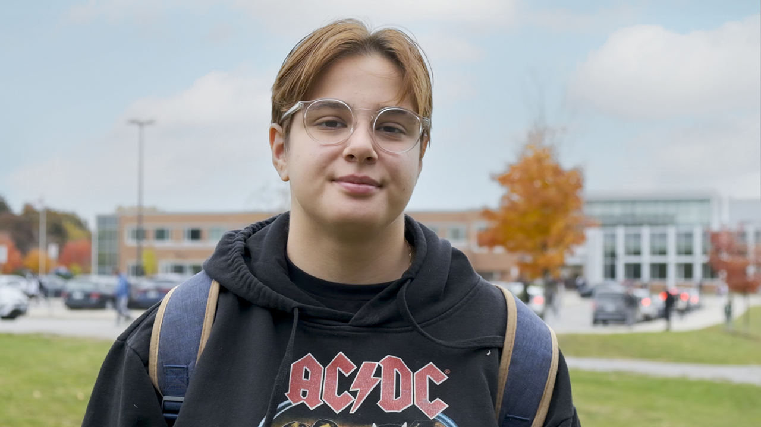

**Providing stable housing for youth to grow**

**Serpil was 15 years old and about to enter the shelter system. Then she found a United Way-funded agency that gave her the stability and security she needed to thrive**

At 15 years old, Serpil was feeling lost. She was struggling with her mental health, had a difficult relationship with her family and was about to be released from a 10-month stay in a mental health treatment home. Serpil didn’t feel like she could go back to living with her parents. She had a friend living in the shelter system and figured that’s where she’d end up.

As she was looking into her options, she learned about the different housing programs offered by [360°kids](https://www.360kids.ca/), a United Way-funded organization in York Region that works to prevent homelessness by helping youth at risk or in crisis transition to a state of safety and stability. The variety of housing and supports they offered appealed to her.

“Before I came into 360, I was struggling a lot mentally,” Serpil says. “I honestly didn't have a lot to look forward to. I didn’t really think I was going to have much of a life in the future.”

She moved into a group home run by the agency. On her very first day at the home, she met Richard, who leads one of the organization’s youth housing programs.

“Her confidence level was low. It was sort of like she didn't know who she could trust, she didn't know what she could disclose about herself, she didn't know if she was safe,” Richard says.

But week by week, as Serpil began to feel comfortable in her new surroundings, she started opening up more and more, allowing others to see the real Serpil and accepting not just the support that was being offered, but also the community.

“I've definitely built a connection,” Serpil says. “It’s nice to have those people that actually treat you like you’re human, instead of treating you like you're just a number or you're just a person in this system and things don't matter. I feel like I'm really supported here.”

The support and stable housing provided by the organization gave her the opportunity to focus on other things. United Way funds housing programs that go beyond providing shelter. They connect people to the supports they need to become financially independent and stay housed in the long term. Through various programs and services, Serpil got a job and learned life skills like cooking and managing money, all of which are setting her up for success in the long-term as she transitions into adulthood.

Now 18 years old, Serpil is thriving. She’s worked on her mental health, built relationships and is on track to graduate high school and apply for apprenticeships.

“She took a lot of our advice and direction. She accepted our support,” Richard says. “There were a few slip backs, but those slip backs helped her grow even more.”

Serpil has also become a model for other youth who are just beginning their journey at the agency. As a member of the 2SLGBTQ+ community, she knows what it’s like to not feel supported by her family and has been vocal in supporting other youth to be themselves.

“When we don't have that support system it's really hard to actually let yourself be out there,” Serpil says. “Once people come to 360, they feel more comfortable with themselves because you don't need to hide that anymore. I feel like that really helps us because there's so many LGBTQ resources here.”

The number of youth experiencing homelessness is increasing, especially 2SLGBTQ+ youth. United Way funds more than 40 housing programs that help thousands of people who are at risk of or experiencing homelessness find or maintain their housing, including targeted programming for young people. These programs provide everything from a welcoming environment for low-income 2SLGBTQ+ youth to diversion programs that connect youth in crisis with a safe bed with a host family to keep them out of traditional shelter services.

“These kinds of things are so important, especially in this day and age, we are seeing an increase of homeless youth on the streets,” Richard says. "Without the help of the United Way, without the support that they've shown us, 360 would not be able to do the work that Serpil has benefitted from.”

As Serpil has grown more independent, she’s left the group home she started her journey at. But even as the house she sleeps in changes, she knows she always has a home with 360°kids. And now, she has plenty to look forward to.

“It really did make a difference for me. I didn't really think I was going to have a future. The housing program gave me more opportunity to see what I can do for myself,” Serpil says. "Putting in that work put a lot of things in the future for me.”